TRƯỜNG THCS KIM SƠN
GV: LÊ THỊ HIẾU

TEST FOR UNIT 7
I. Choose the word whose underlined part in pronounced differently from the rest.
1. a. breaking b. great c. steak d. healthy
2. a. cycle b. bicycle c. fly d. skyscraper
3. a. cycle b. licence c. vehicle d. centre
4. a. reversed b. walked c. stopped d. obeyed
5. a. park b. pavement c. plane d. safety
II. Match the road signs with their meanings.
No Overtaking No Left Turn Pedestrian Crossing Slippery Road Crossroads No Parking Go Ahead Only Turn Right Railway Crossing Hospital Ahead

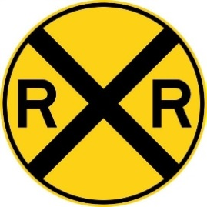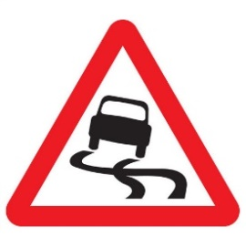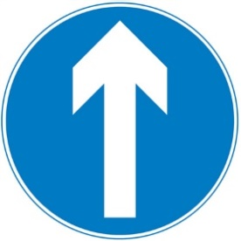
1.______________ 2._____________ 3._____________ 4._____________
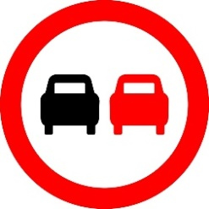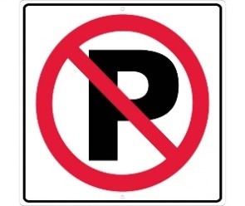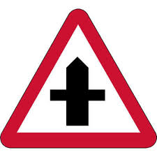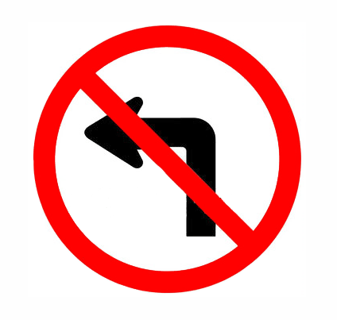
5.____________ 6._____________ 7.______________ 8._____________
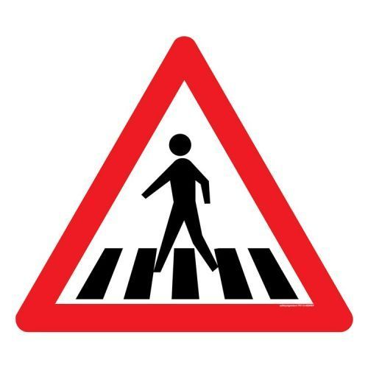
9.____________ 10.______________
III. Choose the best answer a, b, c or d to complete the sentence.
1. You should walk across the street ______ the zebra crossing.
a. on b. at c. in d. from
2. My house is not far from my school, so I usually go ______.
a. on foot b. by foot c. by car d. by boat
3. This morning, I was ______ in a traffic jam and got to school fifteen minutes late.
a. catch b. block c. struck d. stuck
4. Turn on the left turn ______ before you make the turn and slow down.
a. sign b. direction c. signal d. crossing
5. It is ______ to use a hand-held mobile phone while driving or riding.
a. safe b. important c. illegal d. careful
6. ______ does it take you to ride to school? – About 30 minutes.
a. How long b. How far c. How often d. How much
7. A ______ is a part of a road that only bicycles are allowed to use.
a. cycle cross b. cycle lane c. cycle line d. cycle race
8. You ______ cross the street when the light is red.
a. should b. don’t have to c. can d. mustn’t
9. People ______ produce as much rubbish as we do now.
a. use to b. used to c. used to not d. didn’t use to
10. “How far is Vung Tau from Ho Chi Minh City”-“_______”
A. It’s not very far b. it takes about two hours or more.
c. It’s about 120km d. You can get to Vung Tau by boat or bus.
IV. Write the correct from or tense of verbs in brackets.
1. ____________________ (you/ ever/ drive) on the wrong side of the road?
2. My family ______________ (fly) back from our Hong Kong holiday two days ago.
3. Right now, the students _______________ (learn) road signs in the schoolyard.
4. Usually Oanh ______________ (walk) to school, but this week she _____________ (ride) her bike.
5. The driver was so drunk that he ______________ (lose) control of his car.
6. If I have enough money, I _________________ (buy) a racing car.
7. My father ________________ (teach) me to ride a bike when I was seven.
8. Transport used ______________ (be) much slower three hundred years ago.
9. Saudi women weren’t allowed ______________ (drive) a car until recently.
10. In South Africa, you have to let animals ________________ (go) first.
V. Supply the correct form of the words in brackets
1. Young children are expected to show _____________ to their parents. (obey)
2. When cycling on the roads, remember: _____________ first. (safe)
3. Children should avoid _____________ foods such as hamburger and chips. (health)
4. Most road accidents happen because the motorists drive _____________. (care)
5. It is unsafe and _____________ to pass another vehicle on the left. (legal)
6. My _____________ was delayed for over two hours due to bad weather. (fly)
7. Everyone should _____________ obey traffic rules for their own safety. (strict)
8. The policeman _____________ the car to stop with a flashlight. (sign)
9. Signs with red circles are mostly _____________ - that means you can’t do something. (prohibit)
10. This _____________ sign indicates that traffic lights are ahead. (warn)
VI. There is one mistake in each sentence. Find and correct it.
1. I love Thai food now, but I didn’t used to like spicy food.
2. He can drive a bicycle with his hands off the handlebars.
3. We use to walk miles to school every day due to lack of public transport.
4. You are not allowed to drive faster than the number on a limit speed sign.
5. It about 1137 kilometres from Hanoi to Ho Chi Minh City.
6. Bicycles are a cheap and efficient mean of transport.
7. A sign within a red triangle will warn people for something.
8. Be careful when you are on roads. You must drive fast or carelessly!
VII. Match the questions with the correct answers.
1. How does your father travel to word?  2. May I see your driving license, please.  3. Sir, did I do anything wrong?  4. What took you so long?  5. What is the fastest means of transport?  6. How far is it from here to the railway station?  7. Could you tell me how to get to the nearest bus stop, please?  8. How long will it take to get there? | a. Oh, sorry sir, I don’t have it on me.  b. was stuck in a traffic jam.  c. Not very far. Just about 2 km.  d. Go straight ahead, then turn right at the crossroads.  e. Yes, sir, You ran through the stop sign.  f. By motorbike.  g. Twenty minutes.  h. The plane, I think.
VIII. Choose the word which best fits each gap.
Staying safe on foot and bike
Look out for yourself and your friends when out (1)________ foot and bike. Choose the (2) ________ routes you can like quieter, slower roads, with pavements if you’re walking or (3) ________ if you’re going by bike.
It’s easy to get distracted by your phone or by friends, but you need to be (4)________ to traffic. Put your phone away and take your earphones (5)________ when crossing the road. Don’t trust that drivers (6)_______ spot you and be able to stop in time – many drivers go too fast and don’t (7) ________ enough attention, (8)________ anything you can do to protect yourself is a good thing.
1. a. on b. in c. by d. with
2. a. safe b. safer c. safest d. safely
3. a. zebra crossings b. cycle paths c. footpaths d. bumpy roads
4. a. risky b. warning c. serious d. alert
5. a. off b. over c. out d. down
6. a. must b. will c. could d. should
7. a. pay b. make c. turn d. take
8. a. but b. so c. though d. because
IX. Read the text carefully, then do the tasks.
Large cities often have problems that small towns and rural areas do not have. Two of the biggest problems are heavy traffic and the pollution that cars create. Of course. Traffic problems and pollution are not only found in big cities. However, the higher populations and larger number of cars on the roads in cities can make the problems happen more often and with more noticeable effects.
One of the most common traffic problems the large cities have is congestion. As the population of a city increases, so does the number of cars on the road. Cities cannot always improve the number and size of their roads and highways to keep up with the number of cars. The result is traffic congestion, or traffic jams.
When traffic jams happen, cars that are stuck in the congestion continue to run their engines. This creates pollution and is a big problems. Pollution causes health problems for the people in cities and also hurts the environment.
A. Match the words with their meanings.
1. rural a. being too crowded or too full
2. noticeable b. unable to move
3. congestion c. easy to see or recognize
4. traffic jam d. in the countryside, not in the city
5. stuck e. too many vehicles in one place prevents
B. Choose the correct answers.
1. Where do traffic problems and pollution frequently happen?
a. small towns b. rural areas c. big cities d. remote villages
2. According to the passage, what causes traffic congestion in big cities?
a. A lot of city dwellers b. Too many cars on the roads
c. Careless drivers d. Less traffic signs on the streets
3. The high number of cars is caused by_________
a. urban planning b. traffic congestion
c. environmental pollution d. the population
4. The highway and road network is ________ of meeting the requirement of increasing number of vehicles.
a. full b. aware c. incapable d. uncertain
5. Which of the followings is NOT true? 5.
a. Only big cities have the problem of pollution.
b. Traffic jams cause pollution
c. Pollution is a major problem in big cities.
d. Pollution causes health and environmental problems.
X. Make sentences using the words given.
1. The roads/ Vietnam/ too/ narrow/ travel/ easily.
_____________________________________________________
2. How far/ it/ your house/ the bookstore?
_____________________________________________________
3. Mai/ used/ go/ school/ foot/ when/ she/ primary school.
_____________________________________________________
4. It/ very important/ obey/ traffic rules/ when/ use/ road.
______________________________________________________
5. It/ ten kilometres/ the town/ the airport.
______________________________________________________
6. Two days ago/ we/ stuck/ traffic jam/ over two hours.
______________________________________________________
7. Most streets/ city centre/ congested/ rush hour
______________________________________________________
8. you/ use/ have/ tricycle/ when/ child?
______________________________________________________

TEST FOR UNIT 8
I. Choose the word that has the ending pronounced differently from the other.
- A. gripping B. fiction C. violent D. thriller
- A. engaged B. gripped C. laughed D. wrecked
- A. critic B. comedy C. cartoon D. cinema
- A. terrified B. based C. starred D. entertained
- A. feature B. theatre C. screen D. must-see
II. Choose the odd one out
- A. honor B. adventure C. gripping D. action
- A. director B. comedy C. producer D. actress
- A. touching B. hilarious C. scary D. western
- A. awful B. entertaining C. fascinating D. exciting
- A. thrilling B. touching C. terrifying D. must-see
III. Fill in the gap with the type of the film
- A movie that makes you laugh is a _________________
- A movie that makes you scream is a _________________ film
- A story that is exciting with lots of guns and explosions is an ____________ movie
- Movies about future, aliens from space or space travel are ______________films.
- A movie about real life is a ____________________.
- An ____________________ is a film in which drawing of people and animals seem to move
- A film that tells an exciting story about murder and crime is a ________________
- A humorous film about love story is a _____________________.
IV. Choose the correct answer a, b, c, or d to complete the sentences.
- Colin Firth won his first Oscar for best lead actor ___________ England’s King George VI.
- As B. with C. Of D. in
- Twelve Years a Slave is based ______ a true story of Solomon Northup
- in B. by C. on D. from
- “What _________ of film is the Matrix?” – “Science fiction”.
- ranking B. plot C. review D. kind
- Critic say Midnight Run is a must –see ___________ it is funny and exciting.
- Although B. because C. however D. therefore
- Vin Diesel _________ in many action films, including The Fast and Furious series.
- Starred B. made C. produced D. directed
- ___________ an all- star cast, Hotel Artemis was a total box- office failure.
A. Because of B. Although C. Despite D. In spite
7. The special effects in Jurassic Park are ___________! The dinosaurs look so real and alive
A. Visible B. incredible C. terrible D. believable
8. For a ___________, that film wasn’t very funny. I didn’t laugh once.
A. Thriller B. romance C. documentary D. comedy
9. That vampire film was extremely ____________. I had my eyes closed half on the time!
A. hilarious B. moving C. gripping D. scary
10. “Could I ask you a few question about your favorite movies?”____________________
A. That sound good. C. Sure. Go ahead
B. Not a bad idea D. But I don’t want to.
V. Write the correct tense or form of verbs in bracket.
- What is the best horror movie you _____________________ (see) so far?
- Tom Hanks _______________(win) an Oscar for playing Forrest Gump in 1994.
- I ________________ (watch) a very interesting Korean drama at present.
- Kong – Skull Island _____________________ (direct) by Jordan Vogt – Roberts.
- The film was a commercial success although it __________________ (not receive) good reviews from critics.
- __________________ (your brother/ usually/ watch) movies at home or the cinema?
- What __________________ (you/ do) tomorrow night?
- Joanna ________________________ (not be) to the cinema since November.
- The last film I ______________________ (see) at the cinema was an action film called Fast and Furious.
- Clint Eastwood became one of the most respected directors, in spite of ___________ (be) known for his western.
- Supply the correct form of the words in brackets.
- The director was so _______________ with the actors that he fired all of them. (satisfy)
- La la Land was _________________ one of the best –reviewed films of 2016. (famous)
- It was supposed to be a horror film but it wasn’t very ____________________. (frighten)
- Julia Roberts is one of the most famous ____________________ in Hollywood. (act)
- Jennifer Lawrence became a huge star after her excellent ____________ in The Hunger Games. (perform)
- The Day After Tomorrow shows a _____________ and abrupt climate change. (disaster)
- The Ring is probably one of the ____________________ horror films of all time. (scare)
- Despite _______________, Zero becomes the 10th highest grossing film of 2018. (critic)
- I find nature documentaries every ______________. I learn a lot from them. (educate)
- Released in September 2018, The Nun ______________ at the box office despite bad reviews. (success)
VII. Each sentence has a mistake. Find and correct it.
- Two days ago, I see a movie on Netflix with my parents.
- The final Lord of the Rings film is a good example of a made-well action film.
- I read a review of that film and it sounds really interest.
- The film didn’t win any acting Oscars despite of starring Meryl Streep and Robert Redford.
- Frozen is one of the most popular animations of all time.
- My brother likes watching action films although they are fast and exciting.
- Kate Winslet and Leonardo DiCaprio play ill-pated lovers of the romance “Titanic”.
- The film failed to do good business in spite of have a popular star cast.
VIII.Match the answers with the correct questions.
1. Have you ever watched a horror movie?  2. What kind of movies do you like?  3. What is the best movie you’ve seen so far?  4. Who is your favorite actor?  5. Why don’t you like romantic comedies?  6. Let’s go see Avengers, Infinity War tonight.  7. What kind of film is it?  8. Who does the film star? | - Fast and Furious  - Yes, why not?  - Robert Downey Jr., Chris Hemsworth and Mark Ruffalo.  - Because they’re too predictable  - No, I don’t like the feeling of being scared.  - It’s a superhero film  - Vin Diesel  - Action and science fiction
IX. Choose the word which best fits each gap.
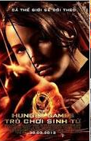
We all know Katniss Everdeen in The Hunger Games, but (1) _________ is the actress who plays her, Jennifer Lawrence?
Jennifer Lawrence was (2) ________ on August 15, 1990 in Kentucky, U.S. When she saw a child, Lawrence knew that she wanted to act, and she began performing in school plays and local theatre. (3) _______ the age of 14, hoping to break into acting and modeling, she went with her mother to New York city to look for work. She (4) _________ in advertisements for MTV and the fashion company H&M and got work as an actress on TV. Her family moved to Los Angeles to allow her to further her career.
In 2010, Lawrence played the (5) _________ in the film Winter’s Bone and she was nominated for many awards including an Oscar. In 2012, she starred in the film The Hunger Games (6) ________ Katniss Everdeen. Lawrence also starred in another (7) ________ film in 2012, director David O. Russell’s Silver Lining Playbook and at the age of 22 she became the second (8) ____________ woman to win the Academy Award for Best Actress for her performance in Silver Lining Playbook.
- A. what B. who C. which D. whom
- A. bear B. beared C. born D. bore
- A. of B. in C. By D. At
- A. appeared B. attended C. starred D. made
- A. acting B. lead C. performance D. scenery
- A. as B. for C. with D. of
- A. complicated B. ordinary C. delicious D. notable
- A. young B. younger C. youngest D. youth
X. Read the text carefully, then do the tasks
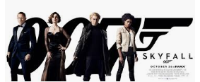
Skyfall is one of the best action films in recent years. Released in 2012, it stars Daniel Craig as secret James Bond and Spanish actor Javier Bardem in the role of Raoul Silva, the villain in this film.
The plot involves a genius computer hacker who is an ex- spy. He wants to take revenge on the organization he used to work for and James Bond has to prevent this from happening. There are a lot of exciting action scenes as Bond pursues him around the world. Can he stop him before it is too late?
The film is set in a variety of locations including Istanbul, Shanghai, Macau, London and Scotland, which gives it a very international atmosphere. The soundtrack is impressive and includes the theme song “Skyfall”, performed by English singer Adele. The acting is also of a very high standard and Bardem brings his character to life with a dazzling and memorable performance.
A. Match the words to their definitions.
- The main bad character in a film  - Very intelligent and skillful  - The story of a film  - A part of a film in which the action happens in one place  - The recorded music from a film  - Extremely impressive | - Soundtrack  - Dazzling  - Scene  - Villain  - Genius  - Plot
B. Answer the question
1. What kind of film is Skyfall.
_________________________________________________________
2. When did the film come out in cinemas?
_________________________________________________________
3. Who are the main character?
_________________________________________________________
4. Who plays the baddie in the film?
_________________________________________________________
5. What is Skyfall about?
_________________________________________________________
6. Where is the film set in?
_________________________________________________________
7. Who sang the theme song for Skyfall?
_________________________________________________________
8. What does the writter say about Javier Bardem’s performance?
_________________________________________________________
XI. Rewrite the sentences using the words in brackets, without changing the meaning.
1. I’ve never seen such a boring movie. (most)
It_________________________________________________________
2. Watching science fiction movies is one of my interests. (arm)
I_________________________________________________________
3. How long is it since you wnt to the cinema. (last)
When_____________________________________________________
4. Although she was scared, she enjoyed watching horror movies. (spite)
In _________________________________________________________
5. Why don’t we go out to dinner and a movie? (suggested)
She ________________________________________________________
6. Despite the heavy rain, they still went hiking. (it)
Although____________________________________________________
7. It was such a gripping movie that I watched it three times. (that)
The movie___________________________________________________
8. The traffic was terrible, but we arrived on time. (despite)
We ________________________________________________________

